Prosciutto and Gruyère Pinwheels
Gourmet | December 1996
yield: Makes about 40 hors d'oeuvres
Can be prepared in 45 minutes or less.

ingredients
3/4 cup finely grated Gruyère (about 3 ounces)
4 teaspoons chopped fresh sage leaves
1 puff pastry sheet (from one 17 1/4-ounce package frozen puff pastry sheets), thawed
1 large egg, beaten lightly
2 ounces thinly sliced prosciutto
print a shopping list for this recipe

preparation
In a bowl combine Gruyère and sage. On a lightly floured surface arrange pastry sheet with a short side facing you and cut in half crosswise. Arrange one half of sheet with a long side facing you and brush edge of far side with some egg. Arrange half of prosciutto evenly on top of pastry, avoiding egg-brushed edge, and top with half of Gruyère mixture. Starting with side nearest you, roll pastry jelly-roll fashion into a log and wrap in wax paper. make another log in same manner. Chill pastry logs, seam sides down, until firm, at least 3 hours, and up to 3 days.
Preheat oven to 400°F. and lightly grease 2 large baking sheets.
Cut logs crosswise into 1/2-inch-thick pinwheels and arrange, cut sides down, 1 inch apart on baking sheets. Bake pinwheels in batches in middle of oven until golden, 14 to 16 minutes. Transfer pinwheels to a rack and cool slightly. Serve pinwheels warm.
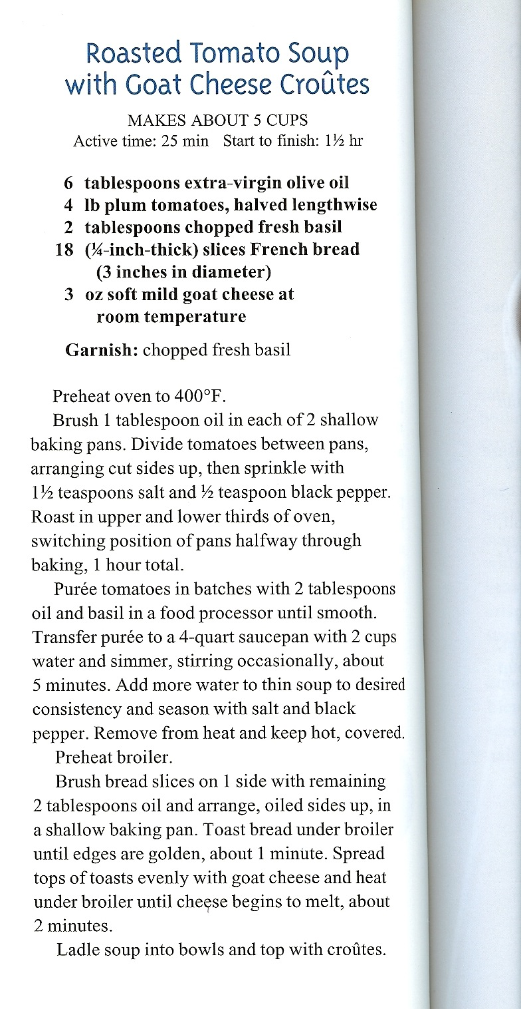
Pasta with Asparagus-Lemon Sauce
Gourmet | May 2000
yield: Serves 4
Though penne is Faith Heller Willinger's pasta of choice for this dish, we tried other types—such as mafalde (broad, rippled noodles similar to... more ›

ingredients
1 lb fresh asparagus, tough ends trimmed
1 teaspoon finely grated fresh lemon zest
1/4 cup extra-virgin olive oil
1 lb penne or pasta of choice
1/2 cup grated Parmigiano-Reggiano
print a shopping list for this recipe

preparation
Cut asparagus into 1-inch pieces, reserving tips separately. Cook asparagus stems in 5 to 6 quarts boiling water with 2 tablespoons salt until very tender, 6 to 8 minutes. Transfer with a slotted spoon to a colander, reserving cooking water in pot, and rinse under cold water. Drain asparagus well and transfer to a food processor or blender.
Cook asparagus tips in same boiling water until just tender, 3 to 5 minutes. Transfer with slotted spoon to colander, reserving boiling water in pot, and rinse under cold water. Drain tips well.
Purée asparagus stems with zest, oil, and 1/2 cup asparagus cooking water. Transfer sauce to a 4-quart saucepan.
Cook pasta in boiling asparagus cooking water until it still offers considerable resistance to the tooth, around three fourths of the recommended cooking time. Reserve 2 cups cooking water and drain pasta.
Add pasta, asparagus tips, and 1/2 cup reserved water to asparagus sauce and cook over high heat, stirring, 3 to 5 minutes, or until pasta is almost al dente and sauce coats pasta. Add more cooking water, 1/4 cup at a time, until sauce coats pasta but is a little loose (the cheese will thicken it slightly).
Stir in Parmigiano-Reggiano and salt and pepper to taste and cook, stirring, until cheese is melted.
Serve immediately.
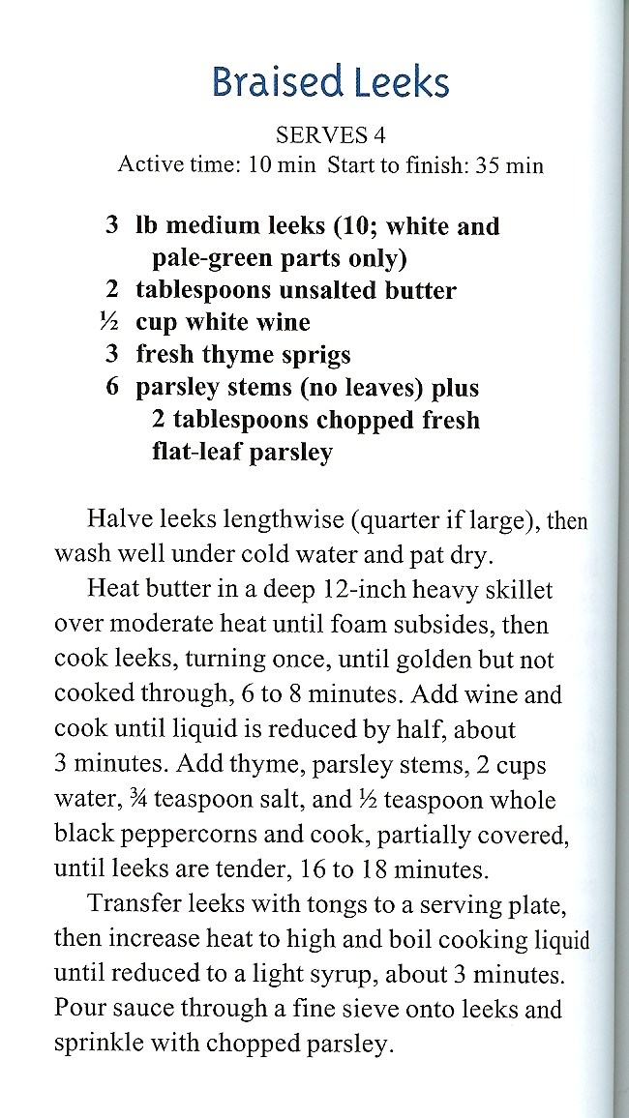
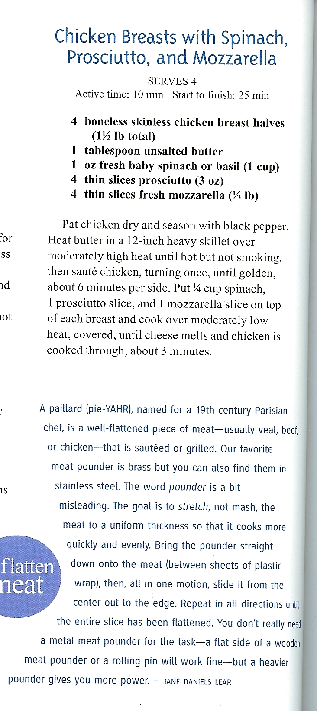
Crepes Suzette
Ingredients
Sweet crepes, recipe follows
1/2 pound butter, softened
4 tablespoons sugar
4 ounces of your favorite liquor
4 scoops of vanilla
ice cream
Directions
Fold your crepes in half twice, so they are in the shape of a triangle. In a non- stick pan over medium heat, melt half of the butter. When it begins to foam remove from heat and add 2 ounces of the liquor and 2 tablespoons of the sugar. Always add alcohol off of the heat to avoid a jumping flame. Use tongs to gently lay crepes into the pan. Turn the crepes to coat. Lay the crepes out on a plate and top with ice cream. Pour remaining sauce over the ice cream. Serve immediately.
Sweet Crepes:
2 large eggs
3/4 cup milk
1/2 cup water
1 cup flour
3 tablespoons melted butter
2 1/2 tablespoons sugar
1 teaspoon vanilla extract
2 tablespoons of your favorite liqueur
Butter, for coating the pan
In a blender, combine all of the ingredients and pulse for 10 seconds. Place the crepe batter in the refrigerator for 1 hour. This allows the bubbles to subside so the crepes will be less likely to tear during cooking. The batter will keep for up to 48 hours.
Heat a small non-stick pan. Add butter to coat. Pour 1 ounce of batter into the center of the pan and swirl to spread evenly. Cook for 30 seconds and flip. Cook for another 10 seconds and remove to the cutting board. Lay them out flat so they can cool. Continue until all batter is gone. After they have cooled you can stack them and store in sealable plastic bags in the refrigerator for several days or in the freezer for up to two months. When using frozen crepes, thaw on a rack before gently peeling apart.

