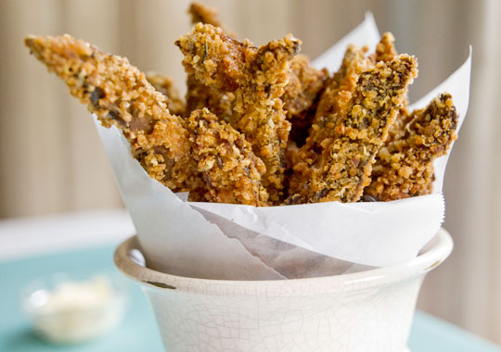

PORTOBELLO “FRIES” WITH TRUFFLED AIOLI
SERVES 8

ABOUT
These are a fun version of French fries. Instead of biting through into potato, you are met with the juicy earthiness of the mushroom. The truffled aioli is an addicting addition.

DIRECTIONS
Trim the stems, remove the gills and gently wipe the Portobello caps with a damp cloth. Cut the Portobello caps into ½ - inch strips.
Combine breadcrumbs, cheese, thyme, salt and pepper in shallow dish. Toss the mushroom “fries” in flour to coat evenly, then dip into the egg wash and roll in breadcrumbs.
Heat about 1 inch of oil in a large skillet over medium heat. Working in batches, place the breaded mushroom strips in the hot oil and cook on all sides until golden brown, 3-4 minutes. Transfer to a paper lined tray.
To make the aioli, combine yolks, lemon juice and garlic in blender, turn the blender on medium and drizzle the canola oil and olive oil into the blender in a steady stream until emulsified into the eggs and is fully incorporated. Season with truffle oil, salt and freshly ground pepper.
PRINT RECIPE
SHARE

INGREDIENTS

THE FRIES
8 Portobello mushrooms
3 eggs, lightly beaten
3 cups fine bread crumbs
1 cup grated pecorino cheese
1 teaspoon dried thyme
1 ½ teaspoons salt
2 teaspoons freshly ground
pepper
½ cup all purpose flour
- canola oil for frying

THE TRUFFLED AIOLI
2 egg yolks
¼ cup fresh lemon juice
1 teaspoon minced garlic
1 cup canola oil
½ cup olive oil
2 tablespoon white truffle oil
- fine sea salt and freshly
ground pepper

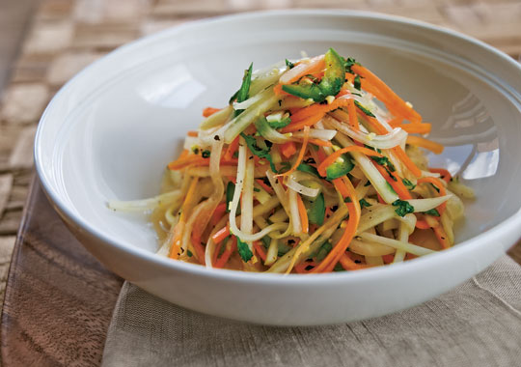

GREEN PAPAYA SALAD
SERVES 4

ABOUT
The julienned flesh of a green papaya is not as sweet as the familiar orangey-pink ripe papaya fruit and it has a nice crunchy texture. The flavor mixes well with green onions, sweet carrot and hot pepper dressed with lime, rice wine vinegar, mint and ginger.

DIRECTIONS
Combine all of the ingredients in a large mixing bowl, season to taste with salt and pepper and toss to evenly coat.
Let the salad marinate for 10 minutes in the refrigerator before serving.
PRINT RECIPE
SHARE

INGREDIENTS
1 large green papaya, peeled,
seeded and julienned
1 small carrot, peeled and
julienned
2 scallions, thinly sliced
1 jalapeno, halved, seeded and
thinly sliced
¼ cup mint leaves, julienned
¼ cup cilantro leaves, julienned
¼ cup lime juice
2 tablespoons rice wine vinegar
2 teaspoon minced ginger
2 teaspoons sugar
1 teaspoon mirin or ½ teaspoon
sugar
- fine sea salt and freshly
ground black pepper

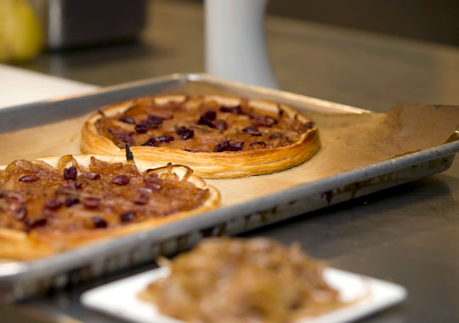

CARAMELIZED ONION AND OLIVE CROUSTADE
SERVES 8

ABOUT
This croustade is a sweet, salty and rich combination of flavors, and is a nice start to any dinner party. It is easy to pick up and eat, no utensils required.

DIRECTIONS
Preheat oven to 450°F.
Heat olive oil in a large skillet over medium heat. Add sliced onion, garlic and thyme. Cook the onion, stirring occasionally until the onions are soft. Reduce heat to medium low and continue cooking for about 30 minutes, stirring occasionally until well caramelized. Season to taste with fine sea salt and freshly ground pepper.
Place the puff dough rounds on a parchment lined baking sheet. Spread the caramelized onion, leaving about ½ - inch around the edges. Top the onions with black olives and Parmesan. Bake the croustades in the oven about for about 15-20 minutes until the crust is golden brown and puffed.
Cut into wedges and serve warm.
PRINT RECIPE
SHARE

INGREDIENTS
¼ cup olive oil
1 small clove garlic, thinly
sliced
2 large onions, thinly sliced
2 sprigs thyme
- fine sea salt and
freshly ground pepper
2 sheet frozen puff dough,
defrosted and trimmed to
6-inch rounds
½ cup black olives, pitted and
halved
- freshly grated Parmesan

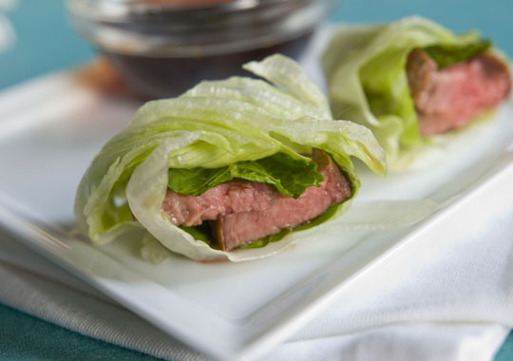

SEARED BEEF LETTUCE ROLLS
SERVES 8

ABOUT
I love this dish. It is so simple but so good and healthier than most hors d'oeuvres. It is light and fresh but flavorful enough to make it a substantial bite of juicy steak wrapped in lettuce.

DIRECTIONS
Stir together the garlic, ginger, soy sauce, chili paste and lime juice in a small mixing bowl. Reserve half to use as a dipping sauce.
Season flank steak on both sides with salt and pepper and pour the remaining marinade over the steak. Let the steak marinate for at least 15 minutes and up to 2 hours.
Heat a large pan over high heat add the canola oil and quickly sear the steak in the hot pan, about 2-3 minutes on each side. Transfer to a cutting board and let cool.
Slice the seared flank steak crosswise into very thin slices.
To make the rolls, lay out a lettuce leaf and trim to about 6 inch square; lay sliced beef in the middle and top with fresh basil and mint leaves. Roll the lettuce leaf around the beef and herbs and tie with three pieces of blanched chives. repeat with the rest of the ingredients.
Slice the rolls into 2-inch rolls and serve with reserved dipping sauce.
PRINT RECIPE
SHARE

INGREDIENTS
1 clove garlic, minced
1 teaspoon grated ginger
½ cup soy sauce
2 teaspoon Sriracha chili paste
¼ cup lime juice
1 pound flank steak
- fine sea salt and freshly
ground black pepper
1 tablespoon canola oil
½ cup basil leaves, loosely
packed
¼ cup mint leaves, loosely
packed
8 large iceburg leaves
24-30 pieces chives, blanched

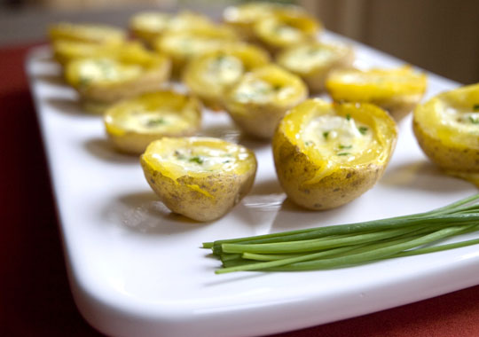

POTATO GOAT CHEESE ROYALE
SERVES 8

ABOUT
This twice baked potato gains a wonderful tang from the goat cheese while remaining decadently rich because of the eggs and cream. Elegant and simple, these are perfect bites of classic comfort.

DIRECTIONS
Cook potatoes in heavily salted water until tender. Drain and let cool.
Preheat the oven to 375°F.
Cut the potatoes in half and scoop out some of the flesh. Place the potato halves on a baking tray and spoon a little goat cheese into the center.
Whisk together the cream and eggs and season with salt and pepper.
Fill the potatoes with the custard mix and sprinkle chives on top.
Bake the potato custards in the oven for about 12-15 minutes, until set.
PRINT RECIPE
SHARE

INGREDIENTS
15 baby Yukon Gold potatoes
(about 1 ½ - 2 inch in
diameter)
4 ounces fresh goat cheese
1 cup cream
2 eggs
- fine sea salt and freshly
ground pepper
¼ cup sliced fresh chives

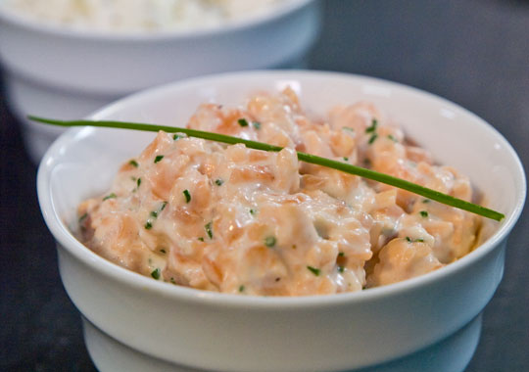

SALMON RILLETTE
SERVES 6

ABOUT
Using both poached, fresh salmon and smoked salmon gives this spread a complex salmon flavor. It is a perfect appetizer and we serve it as an amuse bouche at Le Bernardin.

DIRECTIONS
In a shallow pan, bring the white wine and shallots to a boil. When the shallots are cooked, add the salmon and gently poach the salmon until it is just barely opaque. Remove the salmon from the wine and immediately drain on a towel-lined sheet pan. Strain the wine, reserving the shallots. Place the salmon and shallots in the refrigerator to cool.
Combine the poached salmon and shallots in a mixing bowl with the smoked salmon, chives and some of the mayonnaise and lemon juice—use the mayonnaise and lemon juice sparingly to begin, and adjust to taste. Mix the rillette—do not over-mix or mix too hard. Season to taste with salt and pepper. Serve cold with toasted baguette slices.
PRINT RECIPE
SHARE

INGREDIENTS
2 cups white wine
1 tablespoon minced shallots
1 pound fresh salmon fillet, cut
into 1-inch pieces
3 ounces smoked salmon, diced
2 tablespoons thinly sliced
chive
½ cup mayonnaise
3 tablespoons fresh lemon juice
- fine sea salt and freshly
ground white pepper

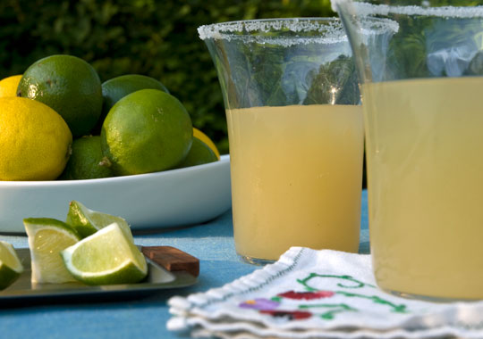

THE GINGER MARGARITA
SERVES 1

ABOUT
There are so many recipes for margaritas; from the most basic to those with ten ingredients. I prefer to let the tequila be the prominent flavor but this one gets a little touch of ginger from a French, ginger liqueur called Domaine de Canton.

DIRECTIONS
Shake with ice and serve in sugar rimmed glasses.
PRINT RECIPE
SHARE

INGREDIENTS
2 ounces Domaine de Canton
Ginger Liqueur
2 ounces tequila
1 ounce lime juice

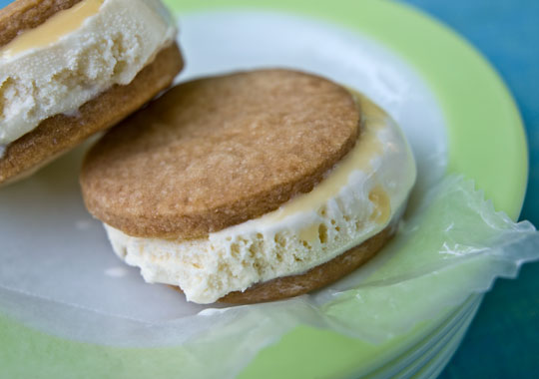

DULCE DE LECHE ICE CREAM SANDWICHES
SERVES 8

ABOUT
This dessert is so fun to make! Cooking cans of sweetened condensed milk in boiling water is kind of like playing in a science lab. The milk cooks to a golden, delicious syrup that can be used to pour over all kinds of desserts. Because it is cooked in the can and never opened, it will keep in the pantry for a long while. Shortbread cookies are one of the easiest cookies to make and when vanilla ice cream and dulce de Leche are squeezed between, a fantastic little personal dessert is created.

DIRECTIONS
Remove the label from the sweetened condensed milk cans. Place the cans in a pot and cover completely with water. Bring the pot to a boil, lower the heat to a simmer and let simmer for about 2 ½ - 3 hours, making sure to add more water as necessary to keep the cans fully submerged in water. Remove the cans of dulce de leche from water and let cool to room temperature.
Preheat oven to 350° F.
Cream together butter, sugar and salt and add the flour and combine. Roll out the dough to ½ -inch on a lightly floured surface. Using a 2 ½ - inch round cutter, cut out shortbread cookies and place on a baking sheet. Bake for 15-20 minutes until golden brown.
To assemble the ice cream sandwiches, open the cans of dulce de leche. Lay half of the shortbread cookies on a tray and place a small scoop of vanilla ice cream on top, lightly push down to make a small indentation and spoon some of the dulce de leche over the ice cream; top with another short bread and place in the freezer until ready to serve.
PRINT RECIPE
SHARE

INGREDIENTS
2 cans sweetened condensed
milk
1 cup butter
½ cup sugar pinch salt
2¼ cups all-purpose flour
1 quart vanilla ice cream

